<Customer Name>
<Project Name>
Software Requirements Document
<Version No.>


 | Prepared By | Reviewed by | Approved By
Name
Role |  | Project Leader/ Team Leader/ Team Member | Project Manager/ Team Leader
Signature
Date

Table of Contents
1.0 Introduction 3
1.1 About this document 3
1.1.1 Purpose & Scope of the document 3
1.1.2 Intended Audience 3
1.2 About the Software System 3
1.2.1 Purpose 3
1.2.2 Scope of the system 3
1.2.3 Exclusions 3
1.2.4 System Perspective 3
1.2.5 System diagram 4
1.2.6 System Environment 4
1.2.7 User Characteristics 4
1.2.8 Impact Of the System 4
1.2.9 Design Constraints 5
2.0 System Requirements 6
2.1 Functional Requirements 6
2.2 Non functional Requirements 6
2.2.1 UI Requirements: Inn 6
2.2.2 Performance Requirements: Pnn 7
2.2.3 Installation, Deployment & Operational Requirements: Onn 7
2.2.4 Reliability 8
2.2.5 Archiving and Purging Requirements: A&Pnn 8
2.2.6 Maintainability & Portability Requirements: MPnn 8
2.2.7 Security Requirements Snn: 8
2.2.8 Cultural & Political Requirements CPnn: 8
2.2.9 Statutory & regulatory requirements SRnn: 9
2.2.10 Online User Documentation and Help System Requirements (DOCnn) 9
2.2.11 Training Requirements (TRnn) 9
3.0 Requirement Summary Table 10
4.0 Make /Buy analysis 11
4.1 Off-the-shelf products as solutions 11
4.2 Reusable components 11
5.0 Open Issues 12
6.0 To be determined Requirements 12
7.0 Annexure 13
7.1 Annexure II: Status of issues raised on requirements 13
7.2 Annexure III: CRAD 14
8.0 Change Log 15

Introduction

About this document

Purpose & Scope of the document
The aim of this project is to design the system which allocates virtual machines to users with the proper authentication system. The user can demand virtual machines based on their need. To get virtual machine user is supposed to enter all credentials such as associate id, project name, duration of vm and software requirements. Which will be authenticated by admin. And user will demand time extension which admin will authenticate with a new password.

Intended Audience
- Cognizant Employees

About the Software System

Purpose
This software will allocate VM based on Employees requirements. To get virtual machine user is supposed to enter all credentials such as associate id, project name, duration of vm and software requirements. Which will be authenticated by admin. And user will demand time extension which admin will authenticate with a new password.

Scope of the system
This product can be further extended for the use of allocating other virtual resources to the employees. Later on, this software can be extended to be used on containers.

Exclusions
Giving personalized/ custom VM as per user requirement isn’t provided in the current system.

System Perspective
This is an independent system which works irrespective of any other larger system.

System diagram

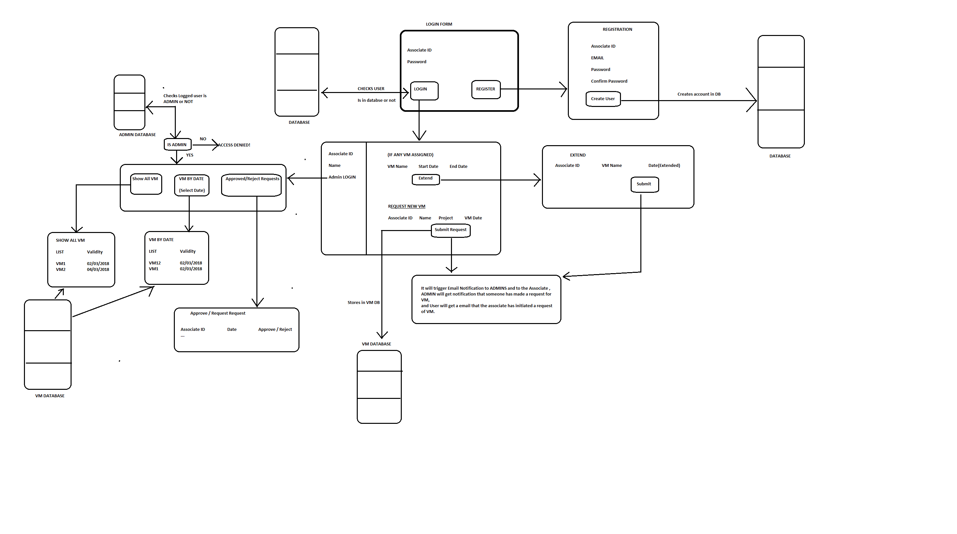

System Environment
This software is developed for the employees who needs VM for project and professional reasons.

User Characteristics
- All Cognizant employees under the BU of Insurance
- All User who worked with the GUIDEWIRE tools.

Impact Of the System
This system is completely built from scratch. This is a totally independent software which has no previous version.

Design Constraints
This software is a standalone software, this is a Desktop application. This software is not compatible for mobile devices.

System Requirements
<There are different ways of grouping the Functional and Non-Functional requirements.
- For every functional requirement, the non-functional requirement could be immediately addressed.
- The functional and non-functional requirements could be consolidated separately.

Functional Requirements

System Functional Requirements
  - User request for New VM through User portal.
  - While requesting for new VM user have to enter the details such Name, Associate ID , Project Name , Reason, and products of guidewire to be installed on VM.
  - User will choose from product options such as below and version of every option.
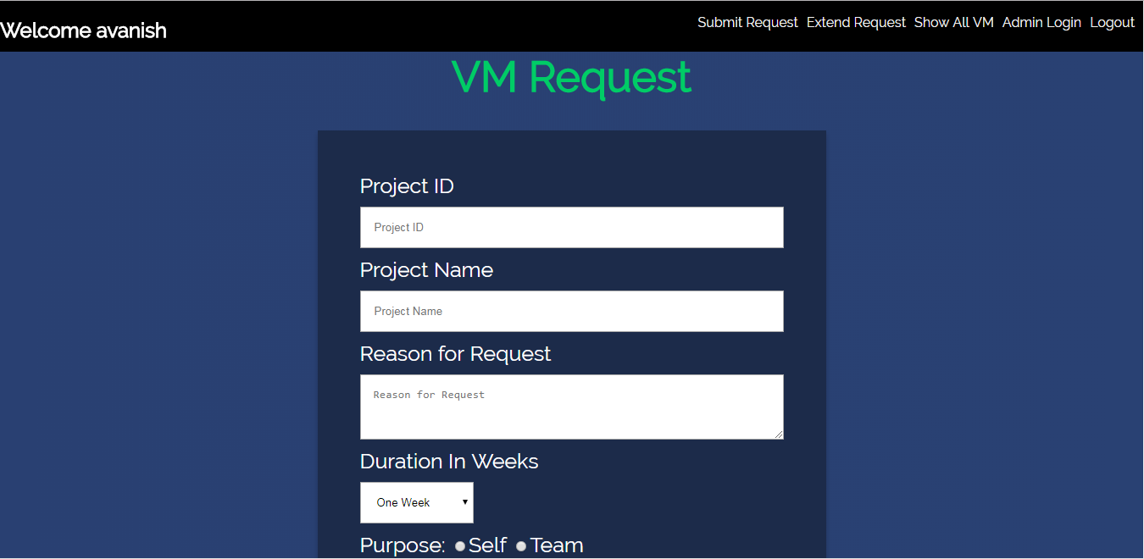
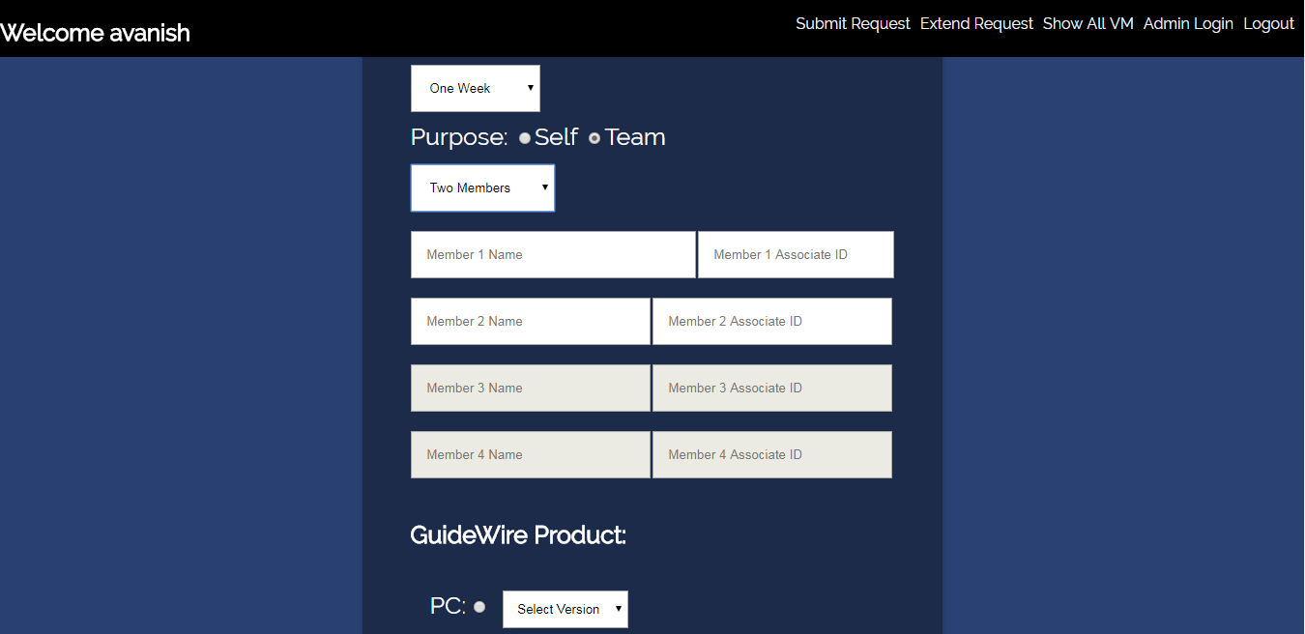
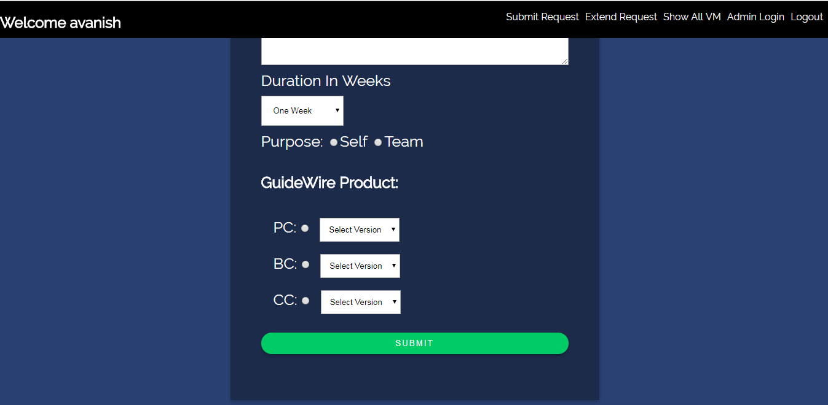
  - Once user will press submit button the program will trigger mail to admin stating for new VM request.

  - The Admin section will get three options on Dashbord.

  - Show all vm, show vm by date and show pending VM.
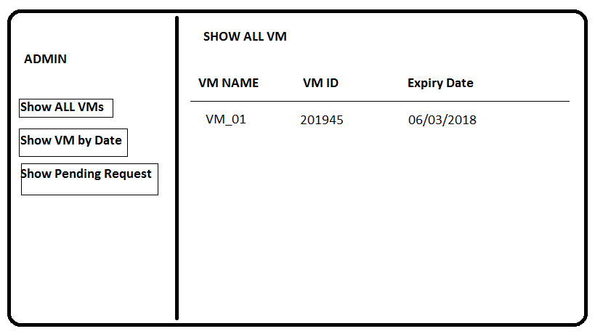
  - if admin will click on show all VM, button the above window will be displayed where admin can see all VMs currently assigned.
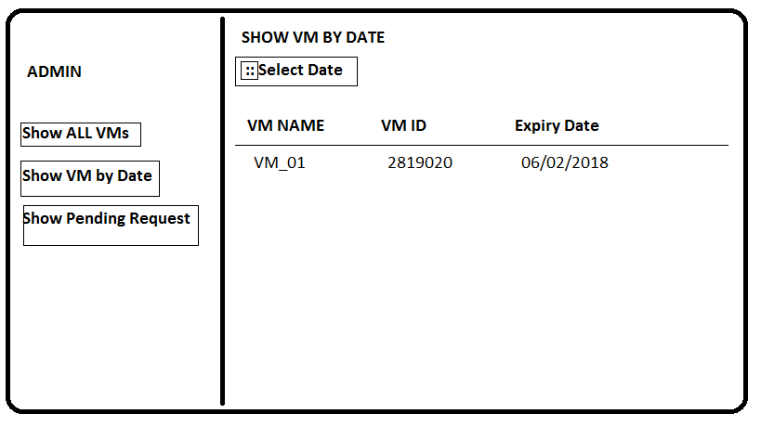
  - If admin selects show VM by date button, the above window will be displayed where admin can see all the VMs as per expiry date.
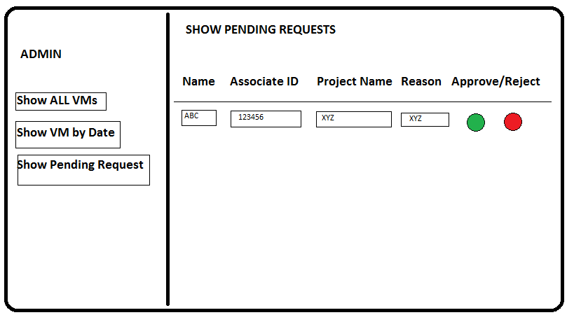
  - If admin selects show pending request button the above window will be displayed
  - From this portal admin can accept or reject request for particular VM.

Non functional Requirements

UI Requirements: Inn
<This sub-section id shall contain an unique Id Inn (nn = 1,2,3...) for each UI requirement and describe the requirement. This should cover the following
- The entire product is a web based portal.
- Admin portal can be open from navigation bar.
- Entire User interface will be very simple and very easy to use.

This sub-section shall provide information on the following:
- The system contains 4 screens, which consist of dashboard for user where one can demand for virtual machine and can request for extension of virtual machine time.
- At first the user will login with the home page and it opens the main page ,that consist of dashboard that allows the user in demanding a virtual machine and extending his current schedule. There is also an admin portal that can be toggled, from the main page that helps in handling these requests.
- There is a session time limit that is set for the user. If the time limit exceeds then the access will be removed and the progress terminated and must be redone again.

Performance Requirements: Pnn
<This sub-section id shall contain an unique Id Inn (nn = 1,2,3...) for each UI requirement and describe the requirement. This should cover the following:
- Speed requirements
- Online Transaction speed, Batch window etc
- Safety critical requirements,
- Precision requirements,
- Reliability and availability requirements
- Capacity Requirements etc.>

Installation, Deployment & Operational Requirements: Onn
<This sub-section id shall contain an unique Id Inn (nn = 1,2,3...) for each UI requirement and describe the requirement. This should cover the following
- High end servers with high RAM ,hard disk and processing power.
- The entire project will be on virtual machines, which allocates different Virtual Machine based on needs.

Reliability
<Requirements for reliability of the system should be specified here. Suggestions>
Availability – specify % of time available (xx.xx%), hours of use, maintenance access, degraded mode operations etc.
Mean Time Between Failures (MTBF) – this is usually specified in hours, but it could also be specified in terms of days, months, or years.
Mean Time To Repair (MTTR) – how long is the system allowed to be out of operation after it has failed?
Accuracy – specify precision (resolution) and accuracy (by some known standard) that is required in the systems output. >

Archiving and Purging Requirements: A&Pnn
<This sub-section id shall contain an unique Id Inn (nn = 1,2,3...) for each UI requirement and describe the requirement. >

Maintainability & Portability Requirements: MPnn
<This sub-section id shall contain an unique Id Inn (nn = 1,2,3...) for each UI requirement and describe the requirement. This should cover the following
- Ease of Maintenance of the system
- Special conditions for System Maintenance
- How long the system is expected to be used
- Are there major upgradation proposed immediately after rollout
- Will the system be replaced by some other system after a certain point?
- Portability requirements etc.

Security Requirements Snn:
- The password generated for each virtual machine should be confidential and must only be known to user and admin.
- All the operations done on virtual machine should not be copied.
- Every user should possess Associate ID and virtual machine password to access Virtual Machine except user only admin could be able to change the password.

Cultural & Political Requirements CPnn:
- There is no such restrictions on the use of this application.

Statutory & regulatory requirements SRnn:
<This sub-section id shall contain an unique Id Inn (nn = 1,2,3...) for each UI requirement and describe the requirement. This should cover the following
- Legal Jurisdiction
- Standards compliance requirements etc.

Online User Documentation and Help System Requirements (DOCnn)
<This sub-section id shall contain an unique Id Inn (nn = 1,2,3...) for documentation requirement and shall cover the following>
- Online user documentation
- Operations Manuals
- User Manual
For non-English clients, the language in which these documents will be delivered will also be specified here.

Training Requirements (TRnn)
<This sub-section id shall contain an unique Id Inn (nn = 1,2,3...) for training requirement>

Requirement Summary Table
<Application 1>
<Module1>
Business Requirement ID | Software Requirements ID | Short Description | Requirement Provider (Originator) | Priority | Complexity | Requirement type | Remarks

Possible values for Requirement Type: Functional, External Interface, User Interface, and Non – Functional etc
<Feature – Refers to the broad features captures in Business Requirements Document. In the absence of BRD, it should be traceable to the proposal but nevertheless numbered and listed>
<This table can be broken down into sub-tables with each sub-table catering to application/module requirements. The application or the module’s name can be prefixed for easy traceability
This summary can also be maintained as a separate Requirements Summary Document and references to the same inserted here. Template for the same is linked.

Make /Buy analysis

Off-the-shelf products as solutions
<List of existing products that should be investigated as potential solutions. Reference any surveys that have been done on these products. Off- the -shelf solutions are identified and the risks associated with them to be documented in this section. Any likely products should be listed here. Also products that must not be used to be considered. >

Reusable components
<Description of the candidate components, either bought-in or built by the company, that could be used by this project. List libraries that could be a source of components. >

Open Issues
<Issues that have been raised and do not yet have a conclusion should be listed in this section against each requirement id.
This should provide the factors that are uncertain and might make significant difference to the system to bring uncertainty out in the open and provide objective input to risk analysis.

To be determined Requirements
<Requirements that will not be part of the final system but may be included in future versions of the product. These should also be classified with unique ids and mentioned in the requirements table. This section captures this information nevertheless to maintain the continuity of requirements for future versions of the product / application>

Annexure

Annexure II: Status of issues raised on requirements
<If CRAD is not used, but some other form of Issue Clarification is used, then that ID may be substituted here
CRAD ID | Requirement ID | Status | Remarks

The following template may be used for formally tracking requirement clarifications.
Requirements Clarification Template

Annexure III: CRAD
<If CRAD was used, the CRAD may be attached here. If some other tool was used reference to the same may be inserted here>

Change Log
Please note that this table needs to be maintained even if a Configuration Management tool is used.
Version Number | Changes made
V1.0 | <First version>
V1.1 | <If the change details are not explicitly documented in the table below, reference should be provided here>
V1.1 | Page no | Changed by | Effective date | Changes effected
V1.2 | <If the change details are not explicitly documented in the table below, reference should be provided here>
V1.2 | Page no | Changed by | Effective date | Changes effected

